**Multi-table Queries Exercise**

**Learning Goal: understanding multi-table queries and implicit joins.**

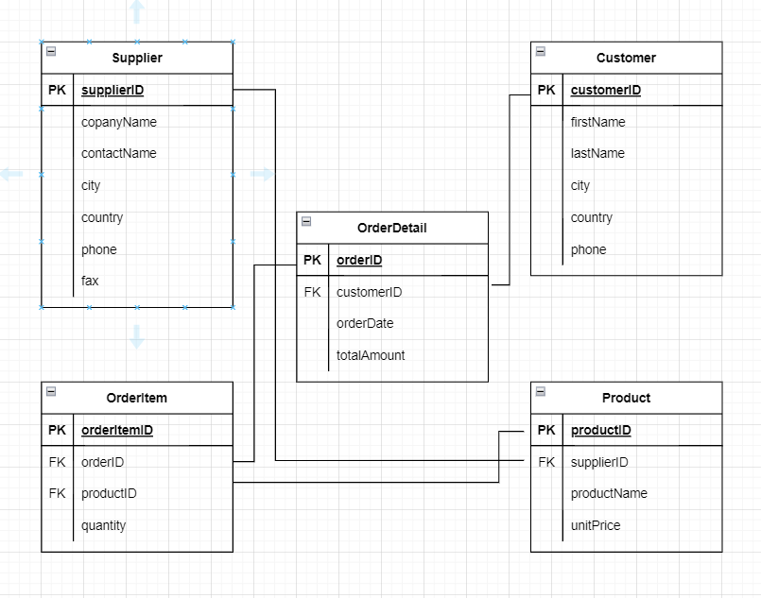

**Given the tables listed.**

1. **Use an implicit join to list the quantity of each product on order.**

**A:**

**SELECT o.quantity, p.\***

**FROM OrderItem o, Product p**

**WHERE o.productID = p.productID**

1. **Use an implicit join to list customer names and their order date.**

**SELECT c.firstName, c.lastName, o.orderDate**

**FROM Customer c, orderDetail o**

**WHERE c.customerID = o.customerID**

1. **Use an implicit join to list the company name, product name and unit price of each product.**

**A:**

**SELECT s.companyName, p.productName, p.unitPrice**

**FROM Supplier s, Product p**

**WHERE s.supplierID = p.supplierID**